**Lab 10 – Normalization 2**

**(2NF, 3NF)**

**NAME – SONI DEV ALPESHBHAI (130759210)**

**Question 1**

**For the following User View, determine the 1, 2 and 3NF The UNF relation has been provided.**

**Premiere Corporation**

**Order Detail Report**

|  |  |  |  |  |  |  |  |
| --- | --- | --- | --- | --- | --- | --- | --- |
| **Order Number** | **Order Date** | **Cust Number** | **Cust Last Name** | **Part Number** | **Part Desc** | **Qnty Ordered** | **Quoted Price** |
| 12489 | 2016-09-02 124 | 124 | Adams | AX12 | Iron | 11 | 14.95 |
| 12491 | 2016-09-02 311 | 311 | Charles | BT04 | GasGrill | 3 | 440.00 |
| BZ66 | Washer | 1 | 399.99 |
| CX11 | MiniBlender | 1 | 11.98 |
| 12494 | 2016-09-04 | 315 | Daniels | CB03 | Bike | 4 | 279.96 |
| 12495 | 2016-09-04 | 256 | Samuels | CX11 | MiniBlender | 2 | 23.96 |
| 12498 | 2016-09-05 | 522 | Nelson | AZ52 | Dartboard | 2 | 12.96 |
| BA74 | Basketbal | 4 | 24.96 |
| 12500 | 2016-09-05 | 124 | Adams | BT04 | GasGrill | 1 | 149.99 |
| 12504 | 2016-09-05 | 522 | Nelson | CZ81 | Treadmill | 2 | 325.98 |

**UNF:**

**ORDER** [PKorderNum, orderDate, custNum, custLname, (partNum, partDesc, qtyOrd, price)]

**1NF:**

**ORDER** [PKorderNum, orderDate, custNum, custLname]

**PARTLIST** [PK partNum, partDesc, qtyOrd, price]

**2NF:**

**ORDER** [PKorderNum, orderDate, custNum, custLname, FK partNum]

**ORDERPART** [FK orderNum, FK partNum, qtyOrd]

**PARTLIST** [PK partNum, partDesc, price]

**3NF:**

**ORDER** [PKorderNum, orderDate, FK custNum, FK partNum]

**ORDERPART** [FK orderNum, FK partNum, qtyOrd]

**PARTLIST** [PK partNum, partDesc, price]

**CUSTOMERLIST** [PKcustNum, custLname]

**Question 2**

**For the following User View, determine the UNF, 1, 2 and 3NF**

Kitchen Utensils report

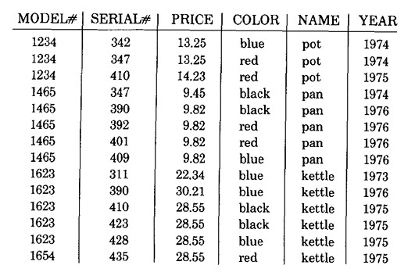

**UNF:**

**ITEM** [PKserialNum, year, price, (modelNum, color, name)]

**1NF:**

**ITEM** [PKserialNum, year, FK price, FK modelNum, FK name, FK color]

**PRICE** [PK price, FK serialNum]

**MODEL** [PK modelNum]

**COLOR** [PK color]

**NAME** [PK name]

**2NF:**

**ITEM** [PKserialNum, year, FK price, FK modelNum, FK name, FK color]

**PRICE** [PK price, FK serialNum]

**MODEL** [PK modelNum]

**COLOR** [PK color]

**NAME** [PK name]

**3NF:**

**ITEM** [PKserialNum, year, FK price, FK modelNum, FK name, FK color]

**PRICE** [PK price, FK serialNum]

**MODEL** [PK modelNum]

**COLOR** [PK color]

**NAME** [PK name]

**Question 3**

**For the following User View, determine the UNF, 1, 2 and 3NF**

**Movie rental report**

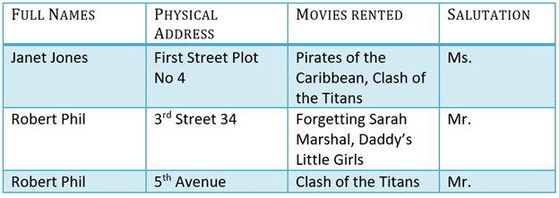

**UNF:**

**LIST** [PK name, title, (address, movies)]

**1NF:**

**CUST** [PK name, title]

**MOVIESRENTED** [PK address, movies]

**2NF:**

**CUST** [PK name, title]

**CUSTRENT** [FK name, FK address, movies]

**ADD** [PK address]

**3NF:**

**CUST** [PK name, title]

**CUSTRENT** [FK name, FK address, movies]

**ADD** [PK address]